LAB 10
Inter-VLAN Routing Using Router-on-a-Stick
Cisco Packet Tracer – Complete Configuration and Verificatio

Objective
Create VLAN 10 (DEV) and VLAN 20 (HR), assign PCs to their VLANs, configure the switch-router link as a trunk, configure router subinterfaces, assign IP addresses and default gateways, and test communication between the VLANs.

2. Create the Topology
Place 1 router, 1 switch, and 4 PCs in Cisco Packet Tracer. Connect the PCs to the switch and connect the switch to the router as shown in Figure 1.
- PC0 → Switch Fa0/1
- PC1 → Switch Fa0/2
- PC2 → Switch Fa0/3
- PC3 → Switch Fa0/4
- Switch Fa0/24 → Router GigabitEthernet0/0
Brief description: The switch connects the PCs, while the router provides Layer-3 communication between the two VLANs.
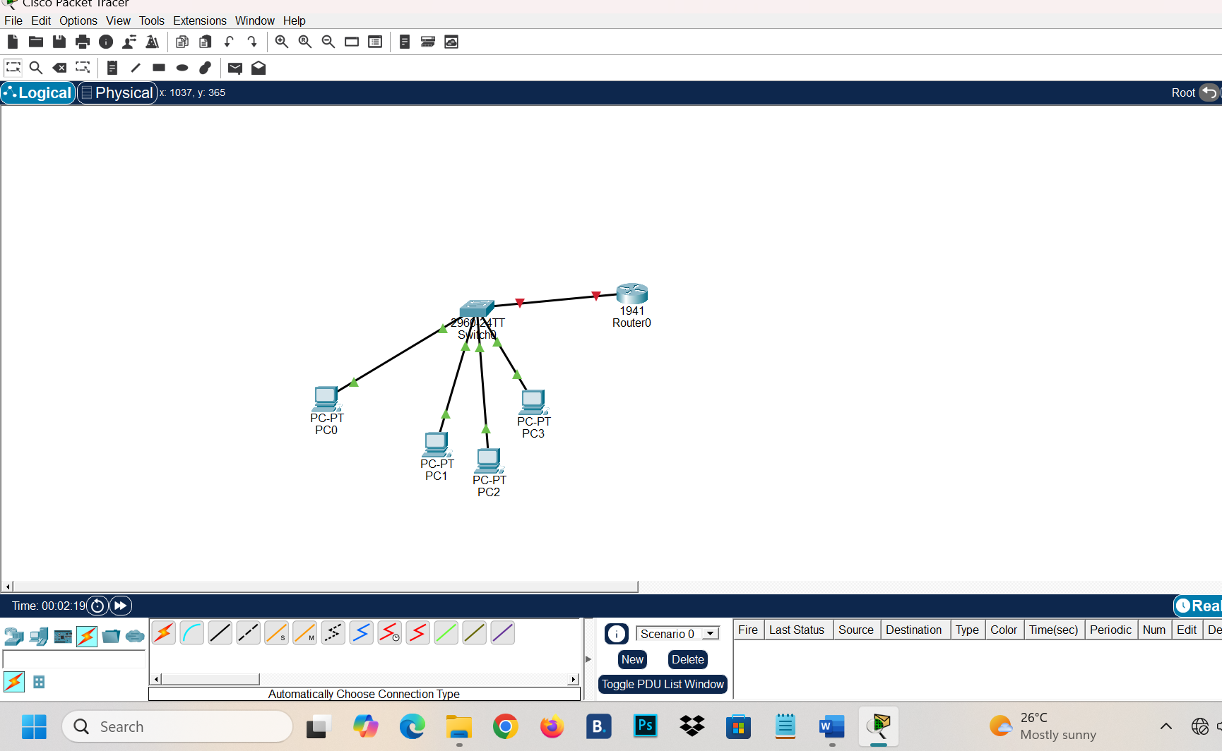

3. Create VLAN 10 and VLAN 20
Brief description: VLAN 10 separates Development traffic and VLAN 20 separates Human Resources traffic.

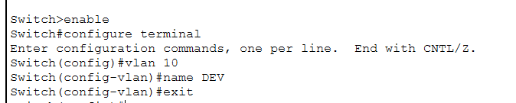

4. Assign PCs to Their VLANs
Brief description: Fa0/1–Fa0/2 are access ports for DEV; Fa0/3–Fa0/4 are access ports for HR.
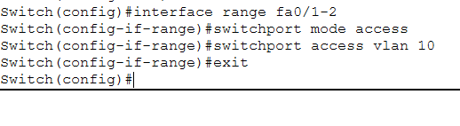

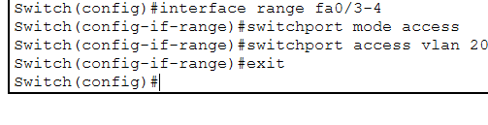

5. Configure the Switch-Router Link as a Trunk
interface fa0/24
switchport mode trunk
exit
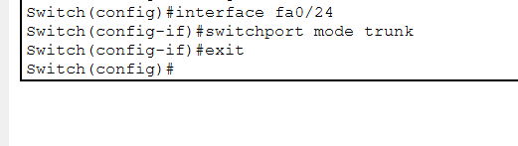
Brief description: The trunk allows VLAN 10 and VLAN 20 traffic to travel over the same physical link to the router.

6. Configure Router Subinterfaces
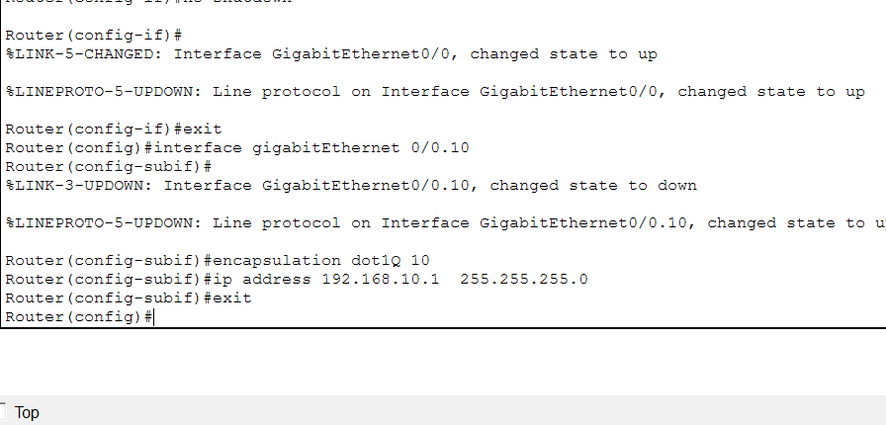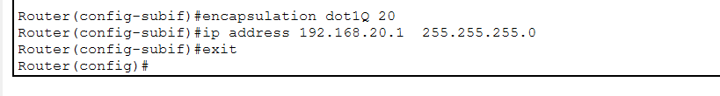
Brief description: Each subinterface is the default gateway for its VLAN. The dot1Q command associates the subinterface with the VLAN tag.

7. Assign IP Addresses and Default Gateways
Device | VLAN | IP Address | Subnet Mask | Default Gateway
PC0 | 10 DEV | 192.168.10.10 | 255.255.255.0 | 192.168.10.1
PC1 | 10 DEV | 192.168.10.11 | 255.255.255.0 | 192.168.10.1
PC2 | 20 HR | 192.168.20.10 | 255.255.255.0 | 192.168.20.1
PC3 | 20 HR | 192.168.20.11 | 255.255.255.0 | 192.168.20.1
Brief description: Each PC gets an address from its VLAN network and uses the router subinterface as its default gateway. In Packet Tracer: open PC → Desktop → IP Configuration.

9. Test Connectivity
From PC0, open Desktop → Command Prompt and test the HR PC:
ping 192.168.20.10
From PC2, test the DEV PC:
ping 192.168.10.10
Expected result: The ping should receive replies, confirming communication between VLAN 10 and VLAN 20 through the router.

10. Verification Commands
Switch# show vlan brief
Switch# show interfaces trunk
Router# show ip interface brief
Final check: VLAN 10 and VLAN 20 exist; Fa0/1–Fa0/2 are in VLAN 10; Fa0/3–Fa0/4 are in VLAN 20; Fa0/24 is a trunk; and router G0/0.10 and G0/0.20 are up/up with the configured IP addresses.

Conclusion
Router-on-a-Stick allows two VLANs to communicate through one physical router interface by using separate router subinterfaces and an 802.1Q trunk.

